**Digital Logic Design (Lab)**

**Project Proposal**

**[Gas Leakage Detector]**

**Submitted To: Syed Mohsin Ali Shah**

**Group Members: Azhar Kamal, Farooq Ahmad Khan, Daniyal Shakeel**

**Reg. Numbers: 2012299,2012302, 2012321**

1. **Summary**

**The purpose and anticipated end result of this proposal**

Liquefied Petroleum Gas (LPG) is a main source of fuel, especially in urban areas because it is clean compared to firewood and charcoal. Gas leakage is a major problem in the industrial sector, residential premises, etc. Nowadays, home security has become a major issue because of increasing gas leakage. Gas leakage is a source of great anxiety with ateliers, residential areas and vehicles like Compressed Natural Gas (CNG), buses, and cars which are run on gas power. One of the preventive methods to stop accidents associated with the gas leakage is to install a gas leakage detection kit at vulnerable places. The aim of this paper is to propose and discuss a design of a gas leakage detection system that can automatically detect, alert and control gas leakage. This proposed system also includes an alerting system for the users. The system is based on a sensor that easily detects a gas leakage.

We have used a LPG **gas sensor module** to detect LPG Gas. When LPG gas leakage occurs, it gives a HIGH pulse on its DO pin and arduino continuously reads its DO pin. When Arduino gets a HIGH pulse from LPG Gas module it activates buzzer which beeps again and again until the gas detector module doesn't sense the gas in environment.

**The working of project, and features of project**

Gas leakage is a serious problem and nowadays it is observed in many places like residences, industries, and vehicles like Compressed Natural Gas (CNG), buses, cars, etc. It is noticed that due to gas leakage, dangerous accidents occur. The Liquefied petroleum gas (LPG), or propane, is a flammable mixture of hydrocarbon gases used as fuel in many applications like homes, hostels, industries, automobiles, and vehicles because of its desirable properties which include high calorific value, less smoke, less soot, and meager harm to the environment. Liquid petroleum gas (LPG) is highly inflammable and can burn even at some distance from the source of leakage. This energy source is primarily composed of propane and butane which are highly flammable chemical compounds. These gases can catch fire easily. In homes, LPG is used mainly for cooking purposes. When a leak occurs, the leaked gases may lead to an explosion. Gas leakage leads to various accidents resulting in both material loss and human injuries. Home fires have been occurring frequently and the threat to human lives and properties has been growing in recent years. The risks of explosion, fire, suffocation are based on their physical properties such toxicity, flammability, etc. The number of deaths due to the explosion of gas cylinders has been increasing in recent years.

The reason for such explosions is due to substandard cylinders, old valves, no regular checking of gas cylinders, worn out regulators and a lack of awareness of handling gas cylinders. Therefore, the gas leakage should be detected and controlled to protect people from danger. An odorant such as ethane Thiel is added to LPG, so that leaks can be detected easily by most people. However, some people who have a reduced sense of smell may not be able to rely upon this inherent safety mechanism. A gas leakage detector becomes vital and helps to protect people from the dangers of gas leakage.

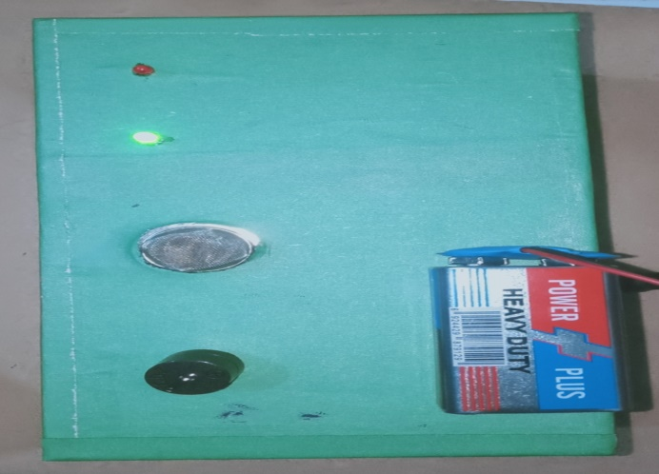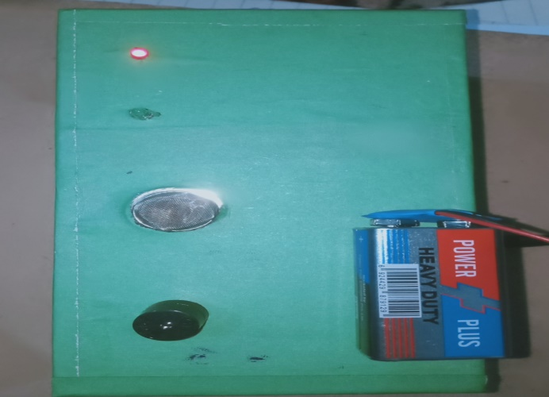

1. **Introduction**

Smoke Detectors arevery useful in detecting smoke or fire in buildings, and so are the important safety parameters. In our project we are going to develop a gas detector by using arduino UNO SMD, where a sound and a light is generate by the detection of gas by the MQ2 gas sensor and it gives us indication that there is some leakage of gas in the certain area. The program is available in different websites we have also copied the program and paste the whole program in the arduino software. Then we have run the program in normal when there is no leakage only the green LED is on when we take a gas lighter near to it and leak some gas then immediately the green LED will stop and red LED will on and the buzzer will give us indication that there is leakage of gas.

In this project semiconductor sensors are used to detect LPG gas. An MQ2 semiconductor sensor is used. Sensitive material of the MQ-2 gas sensor is SnO2, which has lower conductivity in clean air. When the target combustible gas exists, the sensor conductivity increases along with the rising gas concentration. The MQ2 gas sensor has a high sensitivity to Propane, Butane and LPG, and response to Natural gas. The sensor could be used to detect different combustible gasses, especially Methane; it has a low cost and is suitable for different applications. The MQ-2 can detect gas concentrations anywhere from 200 to 10,000 ppm. The sensor’s output is an analog resistance.



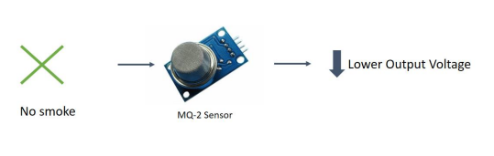

1. **Goals/Objectives**
2. Smoke leakage detectors save lives. Smoke detectors that are properly installed and maintained play a vital role in reducing fire deaths and injuries. If there is a gas leakage in our home, gas spreads fast and we need gas detectors which gives us time to get out from the building.
3. Smoke detectors are designed to warn people in a building when a gas leakage occurs in that building. They are especially useful in residential structures - houses, apartments and mobile homes - or any other building where people may sleep.
4. A gas detector is an electronic gas detection device that automatically senses the presence of gas, as a key indication of gas leakage, and sounds a warning to building occupants.
5. One of the notable future functions of this system is to add a sub system where wastage of gas and the uses of gas can be monitored using this system. The system is flexible as a greater number of sensors and relays can be added to it according to the whole LPG supply setup in those premises.
6. **Evaluation**

We have created our project by using arduino UNO SMD. We have taken a small bread board, Two LEDs red and green, a buzzer three capacitors with the value of 220 omega, MQ2 gas sensor, male jumper wires and a USB cable to connect the arduino with our computer to run the program. First we have taken a jumper from the ground of arduino with the blue end of the bread board and it will become ground. Then we have placed the two LEDs in parallel combination with two resistors. We have taken another jumper wire to the buzzer, placed a resistor. Then we have placed the MQ2 sensor connected it three points. Then we have joined the VCC 5V with one end of bread board. We have connected the arduino with our computer and run the program. We have tested the circuit by taking a small gas lighter closer to it. When we have press the lighter button the sensor will get high voltage and the Red light emits from the Red LED and the buzzer also starts its work, which shows the gas leakage.

1. **Circuit Diagram**

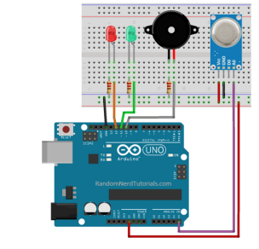

1. **Hardware Components Required**
   1. 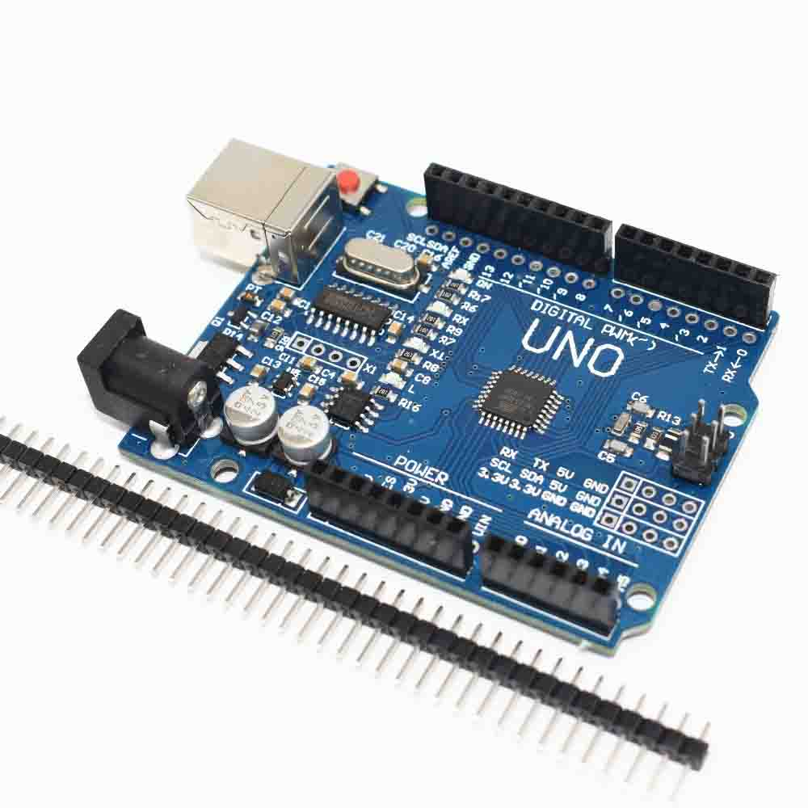**Arduino UNO SMD**

The Arduino Uno SMD is a version of the [Arduino Uno](https://www.arduino.cc/en/Main/ArduinoBoardUno), but uses an surface mount version of the Atmega328P instead of the through-hole version. This version was made in response to a shortage in supply of the through-hole Atmega328P. The board is based on the ATmega328 ([datasheet](http://www.atmel.com/images/Atmel-8271-8-bit-AVR-Microcontroller-ATmega48A-48PA-88A-88PA-168A-168PA-328-328P_datasheet_Complete.pdf)). It has 14 digital input/output pins (of which 6 can be used as PWM outputs), 6 analog inputs, a 16 MHz crystal oscillator, a USB connection, a power jack, an ICSP header, and a reset button. It contains everything needed to support the microcontroller; simply connect it to a computer with a USB cable or power it with a AC-to-DC adapter or battery to get started.

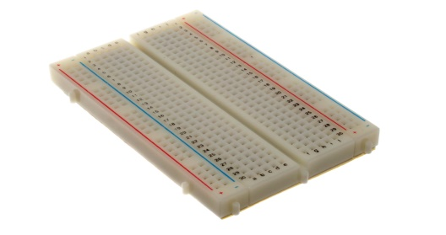**b.** **Bread Board**

A thin plastic board used to hold electronic components (transistors, resistors, chips, etc.) that are wired together. Used to develop prototypes of electronic circuits, breadboards can be reused for future jobs. They can be used to create one-of-a-kind systems but rarely become commercial products.

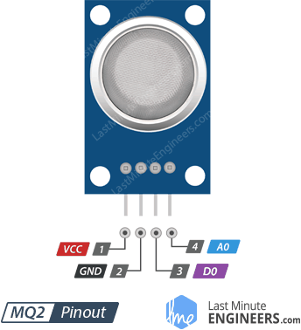c. **MQ2 gas sensor**

MQ2 is one of the commonly used gas sensors in MQ sensor series. It is a Metal Oxide Semiconductor (MOS) type Gas Sensor also known as **Chemiresistors** as the detection is based upon change of resistance of the sensing material when the Gas comes in contact with the material. Using a simple voltage divider network, concentrations of gas can be detected. It can detect LPG, Smoke, Alcohol, Propane, Hydrogen, Methane and Carbon Monoxide concentrations anywhere from 200 to 10000ppm.

**d. Resistors**

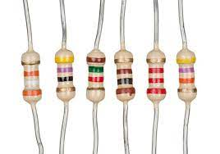A resistor is a [passive](https://en.wikipedia.org/wiki/Passivity_(engineering)) [two-terminal](https://en.wikipedia.org/wiki/Terminal_(electronics)) [electrical component](https://en.wikipedia.org/wiki/Electronic_component) that implements [electrical resistance](https://en.wikipedia.org/wiki/Electrical_resistance) as a circuit element. In electronic circuits, resistors are used to reduce current flow, adjust signal levels, to [divide voltages](https://en.wikipedia.org/wiki/Voltage_divider), [bias](https://en.wikipedia.org/wiki/Biasing) active elements, and terminate [transmission lines](https://en.wikipedia.org/wiki/Transmission_line), among other uses. Resistors are common elements of [electrical networks](https://en.wikipedia.org/wiki/Electrical_network) and [electronic circuits](https://en.wikipedia.org/wiki/Electronic_circuit) and are ubiquitous in [electronic equipment](https://en.wikipedia.org/wiki/Electronics). Practical resistors as discrete components can be composed of various compounds and forms. Resistors are also implemented within [integrated circuits](https://en.wikipedia.org/wiki/Integrated_circuits).

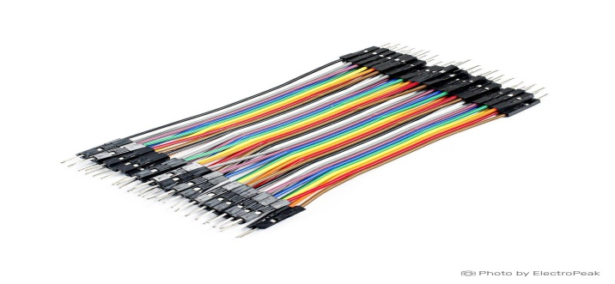**e. Male jumper wires**

Jumper wires typically come in three versions: male-to-male, male-to-female and female-to-female. The difference between each is in the end point of the wire. Male ends have a pin protruding and can plug into things, while female ends do not and are used to plug things into.

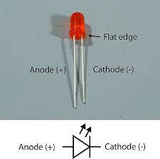LEDS:

In the simplest terms, a light-emitting diode (LED) is a semiconductor device that emits light when an electric current is passed through it. Light is produced when the particles that carry the current (known as electrons and holes) combine together within the semiconductor material.

**Buzzer:**

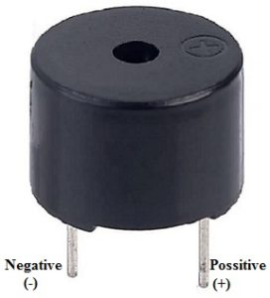A buzzer or beeper is an [audio](https://en.wikipedia.org/wiki/Sound) signaling device,[[1]](https://en.wikipedia.org/wiki/Buzzer#cite_note-1) which may be [mechanical](https://en.wikipedia.org/wiki/Machine), [electromechanical](https://en.wikipedia.org/wiki/Electromechanics), or [piezoelectric](https://en.wikipedia.org/wiki/Piezoelectricity) (*piezo* for short). Typical uses of buzzers and beepers include [alarm devices](https://en.wikipedia.org/wiki/Alarm_devices), [timers](https://en.wikipedia.org/wiki/Timer), and confirmation of user input such as a mouse click or keystroke.

**USB Cable**

****Use it to connect Arduino Uno, Arduino Mega 2560, Arduino 101 or any board with the USB female A port of your computer.

Cable length is approximately 178cm. Cable color and shape may vary slightly from image as our stock rotates.

If you want to have a closer look to USB cables and standard check the USB cable pin outs referral page on pin out

**Power**

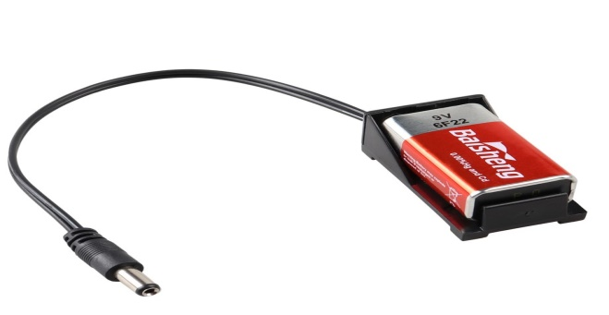The Arduino/Genuino Uno board can be powered via the USB connection or with an external power supply. The power source is selected automatically.

External (non-USB) power can come either from an AC-to-DC adapter (wall-wart) or battery. The adapter can be connected by plugging a 2.1mm center-positive plug into the board's power jack. Leads from a battery can be inserted in the GND and Vin pin headers of the POWER connector.

The board can operate on an external supply from 6 to 20 volts. If supplied with less than 7V, however, the 5V pin may supply less than five volts and the board may become unstable. If using more than 12V, the voltage regulator may overheat and damage the board. The recommended range is 7 to 12 volts.

1. **Practical Applications**

This is an automatic gas detection, control and alert system. In future this system will have a feature where it can notify the emergency services if any accidents happen. This is a low-cost, low power, lightweight, portable, safe, user friendly, efficient, multi featured and simple system device for detecting gas. Gas leakage detection will not only provide us with significance in the health department but it will also lead to raise our economy, because when gas leaks it not only contaminates the atmosphere but also wastage of gases will hurt our economy. The proposed system will cost only 1600 PKR which is easily affordable even for poor people. This device can also be used in the homes to detect leakage of gas.

One of the notable future functions of this system is to add a sub system where wastage of gas and the uses of gas can be monitored using this system. The system is flexible as a greater number of sensors and relays can be added to it according to the whole LPG supply setup in those premises. This is an automatic gas detection, control and alert system. In future this system will have a feature where it can notify the emergency services if any accidents happen. A mobile app and web-based app for real time monitoring also will be added. In the user app for this system many smart features will be added. The overall features will make the system safer for the users. The system will be optimized for use in many places like the car, the home, industries and many other places.